Chapter 11, Solution 70.

Design a problem to help other students to better understand power factor correction.

Although there are many ways to work this problem, this is an example based on the same kind of problem asked in the third edition.

Problem

An 880-VA, 220-V, 50-Hz load has a power factor of 0.8 lagging. What value of parallel capacitance will correct the load power factor to unity?

Solution

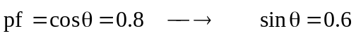
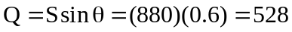

If the power factor is to be unity, the reactive power due to the capacitor is
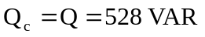
But 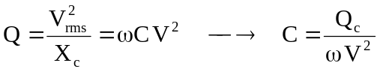
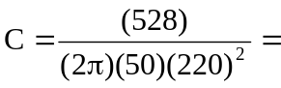34.72 µF

